

**DEPARTMENT OF ELECTRONICS AND COMMUNICAION ENGINEERING**

**Subject: DIGITAL ELECTRONICS& MICROCONTROLLERS (ECH308B-T/P)**

**Branch: CSE**

**Course: B.Tech 5th SEM**

**TUTORIAL -4: Combinational Circuit**

CO3. Analyze different types of digital electronic circuits using various mapping and logical tools and know the techniques to prepare the most simplified circuit using multiple mapping and mathematical methods.

1. If AB=00 and AB=01 what is the value for C and S?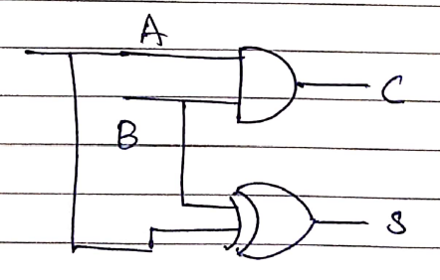
2. The network shown in the figure implements--------------------gate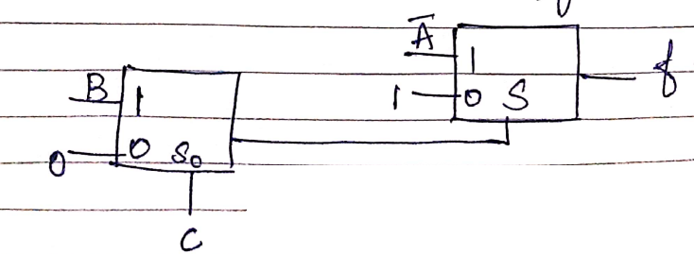
3. Implement the Boolean function using 4x1 Mux

F(A, B, C, D)=Ʃ(0,1,4,67,9,11,15)

1. The logic realized by the circuit is 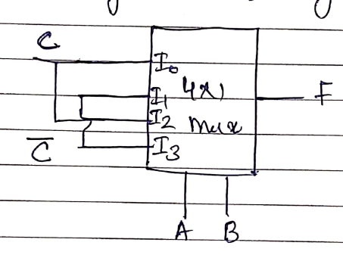
2. How many 8x1 Mux are required to get 64x1 Mux